Fig.S1 Crystal packing of FcL.
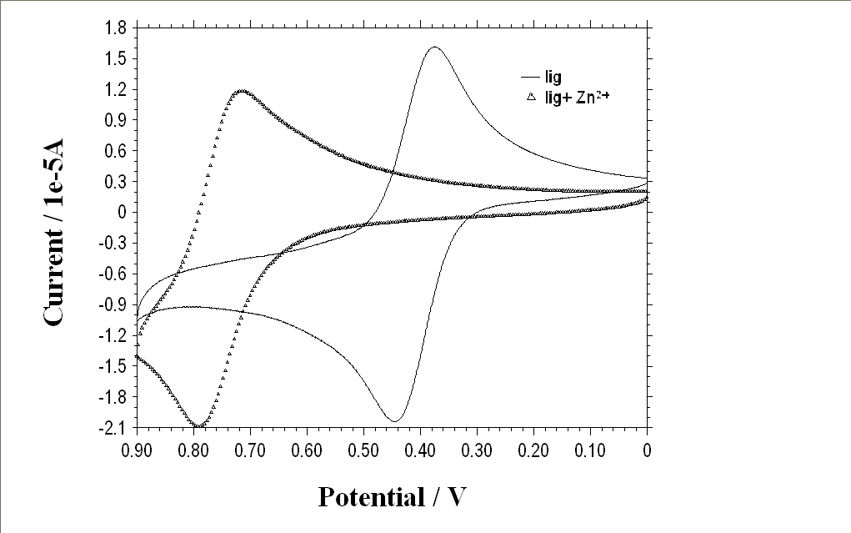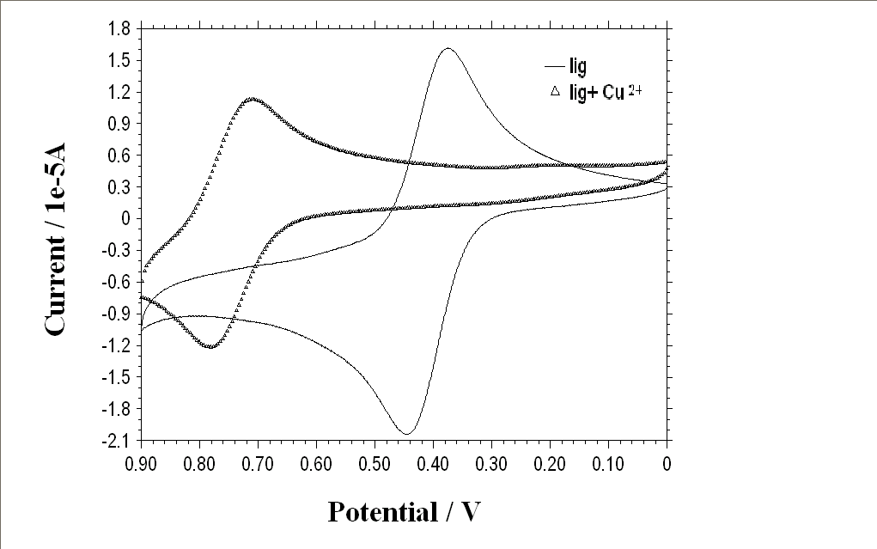
Fig. S2 CVs of FcL and [FcL + Zn²⁺(2 eq.)] Fig. S3 CVs of FcL and [FcL + Cu²⁺(2 eq.)]
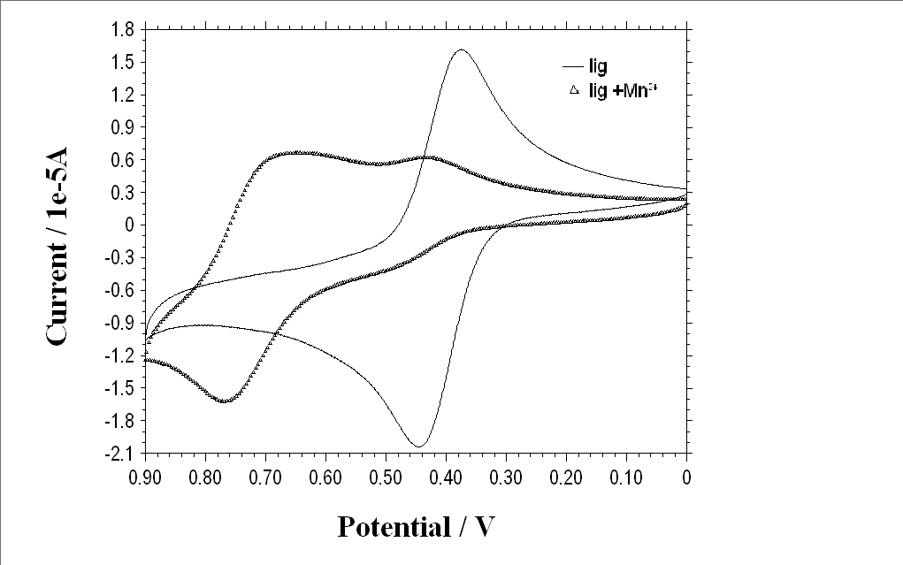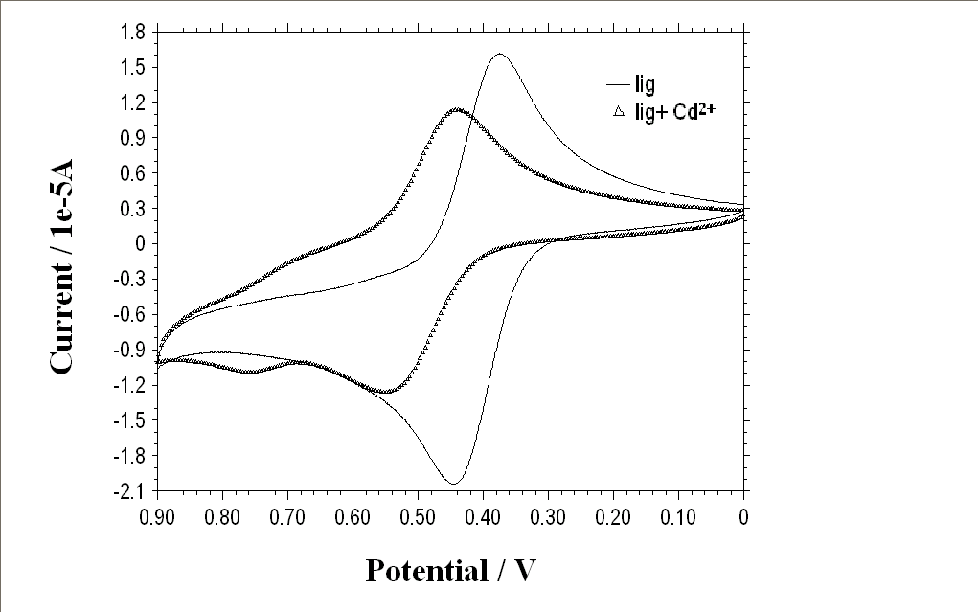
Fig. S4 CVs of FcL and [FcL + Mn²⁺(2 eq.)] Fig. S5 CVs of FcL and [FcL + Cd²⁺(2 eq.)]
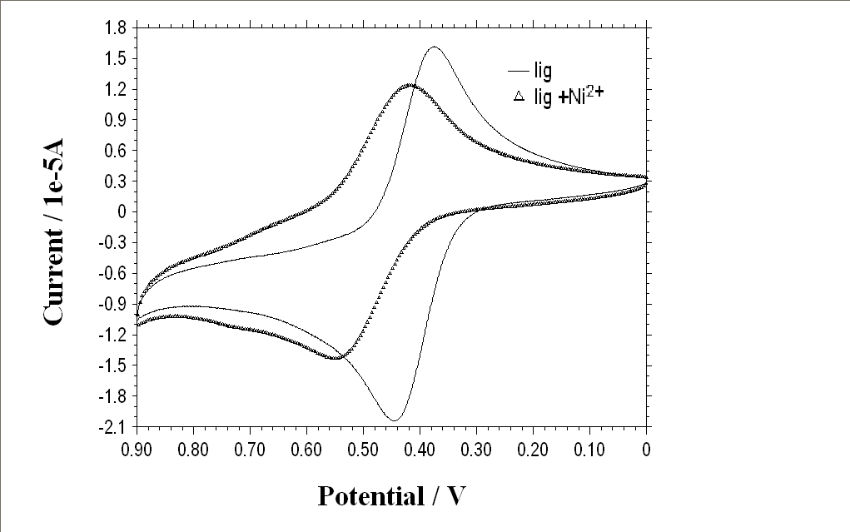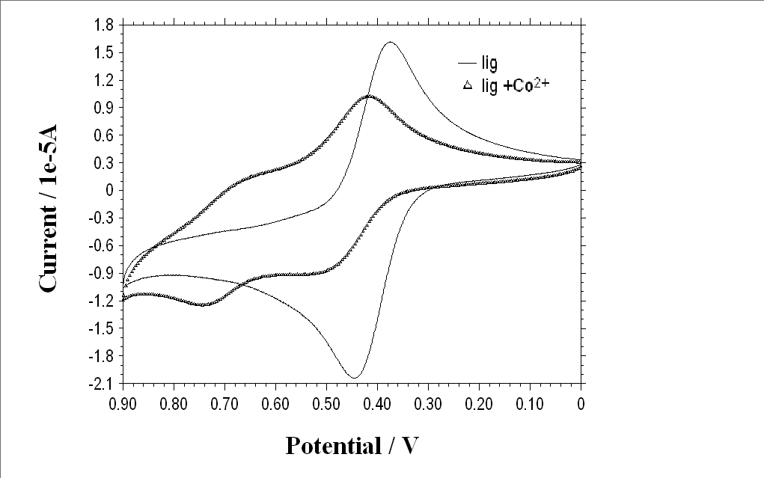
Fig. S6 CVs of FcL and [FcL + Ni²⁺(2 eq.)] Fig. S7 CVs of FcL and [FcL + Co²⁺(2 eq.)]

