**Supporting Information**

**含C^N-螯合配体环戊二烯基铱抗癌配合物**

路小敏 田梦 田珍珍 田来进 李梦琪 黄静 刘哲*

（曲阜师范大学抗癌药物开发与诊疗应用研究所，山东省生命有机分析重点实验室，山东省绿色天然产物及医药中间体开发重点实验室，化学与化工学院，曲阜 273165）

**Potent cyclopentadienyl iridium anticancer complexes containing C,N-chelating ligands**

Xiaomin Lu Meng Tian Zhenzhen Tian Laijin Tian Mengqi Li Jing Huang Zhe Liu*

（*The Key Laboratory of Life-Organic Analysis and Key Laboratory of Pharmaceutical Intermediates and Analysis of Natural Medicine, Department of Chemistry and Chemical Engineering, Qufu Normal University, Qufu273165, China*）

*\*Phone:+86 537 4455228*

*E-mail:liuzheqd@163.com*

Contents

**Tables S1-S7**S1-S7

**Figures S1-S4**S8-S11

**Table S1.** Crystallographic data for [(*ƞ*5-C5Me4H)IrCl2]2 (**dimer1**), [(*ƞ*5-Cpxph)Ir(BIMA)Cl] (**A3**) and [(*ƞ*5-Cpxph)Ir(MBIA)Cl] (**B3**).

|  |  |  |  |
| --- | --- | --- | --- |
|  | **dimer1** | **A3** | **B3** |
| Formula | C18H26Cl4 Ir2 | C23H25ClIrN | C29H29ClIrNO |
| MW | 768.59 | 543.09 | 635.18 |
| Cryst | yellow block | yellow block | red block |
| Cryst size(nm) | 0.36 x 0.22 x 0.20 | 0.56 x 0.36 x 0.18 | 0.40 x 0.22 x 0.18 |
| λ(nm) | 0.071073 | 0.071073 | 0.071073 |
| Temp(K) | 295(2) | 295(2) | 295(2) |
| Cyst syst | Monoclinic | Monoclinic | Monoclinic |
| Space group | P21/c | P21/n | P21/n |
| α(˚) | 90 | 90 | 90 |
| β(˚) | 101.9640(10) | 106.2320(10) | 117.5770(10) |
| γ(˚) | 90 | 90 | 90 |
| a(nm) | 1.57447(11) | 0.90966(6) | 1.22081(8) |
| b(nm) | 0.82189(6) | 1.54671(10) | 1.77525(12) |
| c(nm) | 1.67294(12) | 1.51406(9) | 1.27922(9) |
| Vol(nm3) | 2.1178(3) | 2.0453(2) | 2.4574(3) |
| Z | 4 | 4 | 4 |
| R(*Fo2*) | 0.0363 | 0.0302 | 0.0305 |
| Rw(*Fo2*) | 0.0870 | 0.0685 | 0.0563 |
| GOF | 1.027 | 1.048 | 1.043 |

**Table S2.** Selected Bond Lengths (nm) and Angles (deg) for [(*ƞ*5-C5Me4H)IrCl2]2 (**dimer1**), [(*ƞ*5-Cpxph)Ir(BIMA)Cl] (**A3**) and [(*ƞ*5-Cpxph)Ir(meth)Cl] (**B3**).

|  |  |  |  |
| --- | --- | --- | --- |
|  | **dimer1** | **A3** | **B3** |
| Ir-C(cyclopeanta-  dienyl) | 0.2113(7)  0.2141(7)  0.2120(7)  0.2144(7)  0.2147(7) | 0.2150(4)  0.2180(4)  0.2253(4)  0.2246(4)  0.2141(4) | 0.2161(3)  0.2281(3)  0.2244(3)  0.2171(3)  0.2135(3) |
| Ir−C(centroid) | 0.1750 | 0.1822 | 0.1831 |
| Ir−X1 | 0.24468(18) | 0.2037(4) | 0.2033(4) |
| Ir−X2 | 0.24455(17) | 0.2084(3) | 0.2095(3) |
| Ir−Cl | 0.23836(19) | 0.23921(10) | 0.24030(9) |
| X1−Ir−X2 | 80.40(6) | 77.73(16) | 77.83(13) |
| X1−Ir−Cl | 87.83(8) | 87.75(12) | 86.98(9) |
| X2−Ir−Cl | 87.49(7) | 84.56(9) | 86.52(8) |

X1 = carbon donor group and X2= nitrogen donor group in [(*ƞ*5-Cpxph)Ir(benz)Cl] (**A3**) and [(*ƞ*5-Cpxph)Ir(meth)Cl] (**B3**); for the [(*ƞ*5-C5Me4H)IrCl2]2 (**dimer1**), X1 = first bridging Cl and X2 = second bridging Cl.

**Table S3.** Extent of 9-EtG and 9-MeA Adduct Formation for Complexes **A1**-**B4** at 298 K over 24 h.

|  |  |  |
| --- | --- | --- |
| Complex | G  adduct (%) | A  adduct (%) |
| [(*ƞ*5-C5Me4H)Ir(BIMA)Cl] (**A1**) | 0 | 0 |
| [(*ƞ*5-Cp*)Ir(BIMA)Cl] (**A2**) | 0 | 0 |
| [(*ƞ*5-Cpxph)Ir(BIMA)Cl] (**A3**) | 0 | 0 |
| [(*ƞ*5-Cpxbiph)Ir(BIMA)Cl] (**A4**) | 0 | 0 |
| [(*ƞ*5-C5Me4H)Ir(MBIA)Cl] (**B1**) | 0 | 0 |
| [(*ƞ*5-Cp*)Ir(MBIA)Cl] (**B2**) | 0 | 0 |
| [(*ƞ*5-Cpxph)Ir(MBIA)Cl] (**B3**) | 0 | 0 |
| [(*ƞ*5-Cpxbiph)Ir(MBIA)Cl] (**B4**) | 0 | 0 |

**Table S4.** The TONs of Complexes **A1**-**B4** at 298 K over 8 h.

|  |  |  |
| --- | --- | --- |
| Complex | | TON |
| [(*ƞ*5-C5Me4H)Ir(BIMA)Cl] (**A1**) | 13.6 ± 0.5 |
| [(*ƞ*5-Cp*)Ir(BIMA)Cl] (**A2**) | 31.0 ± 0.8 |
| [(*ƞ*5-Cpxph)Ir(BIMA)Cl] (**A3**) | 21.9 ± 0.4 |
| [(*ƞ*5-Cpxbiph)Ir(BIMA)Cl] (**A4**) | 10.7 ± 0.6 |
| [(*ƞ*5-C5Me4H)Ir(MBIA)Cl] (**B1**) | 17.1 ± 0.1 |
| [(*ƞ*5-Cp*)Ir(MBIA)Cl] (**B2**) | 29.5 ± 0.4 |
| [(*ƞ*5-Cpxph)Ir(MBIA)Cl] (**B3**) | 18.6 ± 0.3 |
| [(*ƞ*5-Cpxbiph)Ir(MBIA)Cl] (**B4**) | 15.1 ± 0.7 |

**Table S5.** Cell cycle analysis carried out by flow cytometry using PI staining after exposing Hela cells to complexes **A4** and **B4**. Concentrations used in all cases were 0.25 × IC50, 0.5 × IC50 and IC50 values. Data are quoted as mean ± SD of three replicates.

|  |  |  |  |  |
| --- | --- | --- | --- | --- |
| Complex | | Population (%) | | |
| G1 phase | S phase | G2/M phase |
| **A4** | 0.25 × IC50 | 55.0 ± 0.6 | 34.2 ± 0.1 | 10.7 ± 0.5 |
| 0.5 × IC50 | 60.1 ± 0.5 | 29.2 ± 0.3 | 10.6 ± 1.0 |
| 1× IC50 | 68.0 ± 0.8 | 20.3 ± 0.7 | 11.6 ± 0.4 |
| **B4** | 0.25 × IC50 | 55.0 ± 0.3 | 34.6 ± 0.5 | 8.3 ± 1.0 |
| 0.5 × IC50 | 62.6 ± 0.2 | 28.4 ± 0.7 | 9.0 ± 0.8 |
| 1 × IC50 | 65.0 ± 1.0 | 27.1 ± 0.3 | 7.8 ± 0.9 |
| control | | 48.4 ± 0.8 | 39.0 ± 0.7 | 12.1 ± 0.4 |

**Table S6.** Flow cytometry analysis to determine the percentages of apoptotic cells, using Annexin V-FITC vs PI staining, after exposing Hela cells to complexes **A4** and **B4**. Concentrations of complexes used were IC50 and 2 × IC50 values.Data are quoted as mean ± SD of three replicates.

|  |  |  |  |  |  |
| --- | --- | --- | --- | --- | --- |
| Complex | | Population (%) | | | |
| Viable | Early apoptosis | Late apoptosis | Non-viable |
| **A4** | 1 × IC50 | 93.89 ± 0.9 | 0.77 ± 0.3 | 4.95 ± 0.1 | 0.39 ± 0.2 |
| 2 × IC50 | 73.04 ± 0.1 | 2.64 ± 0.05 | 23.52 ± 0.2 | 0.79 ± 0.5 |
| **B4** | 1 × IC50 | 94.29 ± 0.5 | 0.89 ± 0.2 | 4.50 ± 0.04 | 0.32 ± 0.3 |
| 2 × IC50 | 71.99 ± 0.7 | 1.98 ± 0.1 | 25.53 ± 0.03 | 0.50 ± 0.1 |
| control | | 93.90 ± 0.8 | 1.27 ± 0.06 | 4.46 ± 0.3 | 0.37 ± 0.1 |

**Table S7.** ROS induction in Hela cancer cells treated with complexes **A4** and **B4**. Concentrations of complexes used were 0.25 × IC50 and 0.5 × IC50 values.Data are quoted as mean ± SD of three replicates.

|  |  |  |  |
| --- | --- | --- | --- |
| Complex | | Population (%) | |
| Cell in Low ROS Levels | Cell in High ROS Levels |
| **A4** | 0.25 × IC50 | 5.33 ± 0.2 | 94.62 ± 0.1 |
| 0.5 × IC50 | 5.53 ± 0.3 | 95.11 ± 0.8 |
| **B4** | 0.25 × IC50 | 3.98 ± 0.5 | 96.02 ± 0.2 |
| 0.5 × IC50 | 3.90 ± 0.2 | 96.01 ± 0.8 |
| Untreated cell’s (negative control) | | 98.43 ± 0.9 | 1.40 ± 0.9 |
| CCCP treated cells (positive control) | | 10.79 ± 0.7 | 85.37 ± 3 |

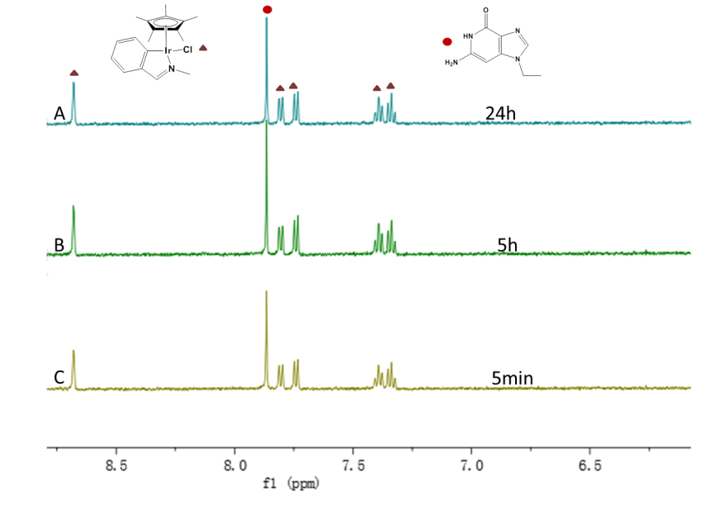

**Figure S1.** Low field region of the 1H NMR spectra showing reaction of **A2** with 9-ethylguanine. (A) 5 min; (B) 5 h; (C) 24 h, after addition of 1 mol equiv 9-ethylguanine to an equilibrium solution of complex **A2** (1.0 mmol/L) in 20%MeOD-*d*4/80% D2O (v/v) at 298 K.

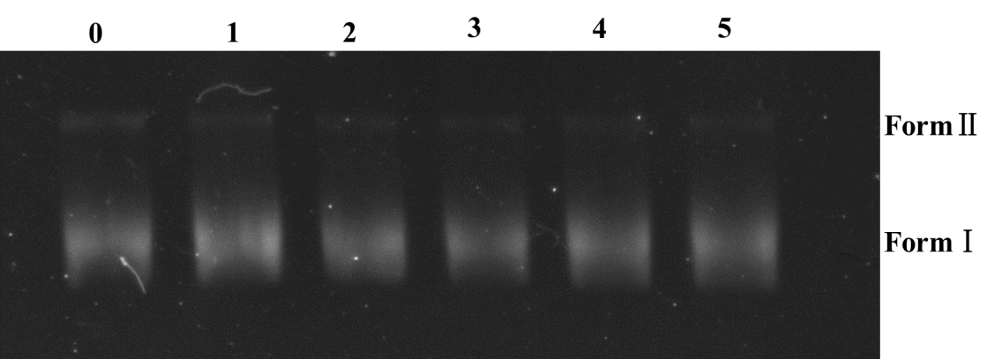

**Figure S2.** Agarose gel electrophoresis patterns for the cleavage of pBR 322 DNA by various concentrations of complex **B2** cleavage conditions: 10 umol/L DNA; 1 mmol/LTris–CH3COOH buffer; pH 8; 37℃ for 24h. Lane 0: DNA control; Lane 1: DNA + 0.1 mmol/L **B2**; Lane 2: DNA + 0.2 mmol/L **B2**; Lane 3: DNA + 0.3 mmol/L **B2**; Lane 4: DNA + 0.4 mmol/L **B2**; Lane 5: DNA + 0.5 mmol/L **B2**.

**(A) (B)**

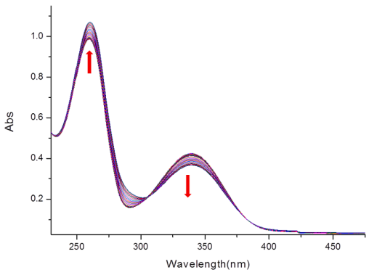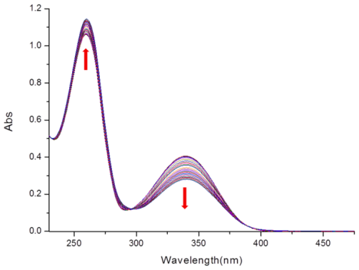

**(C) (D)**

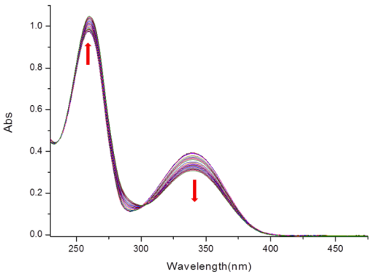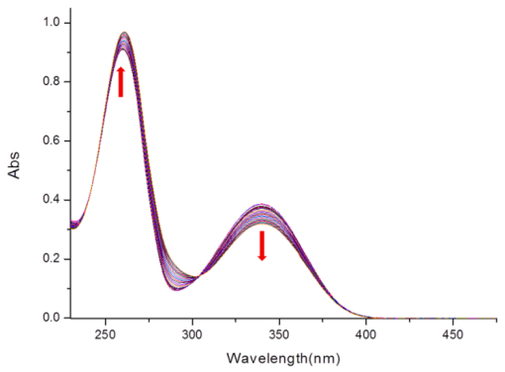

**(E) (F)**

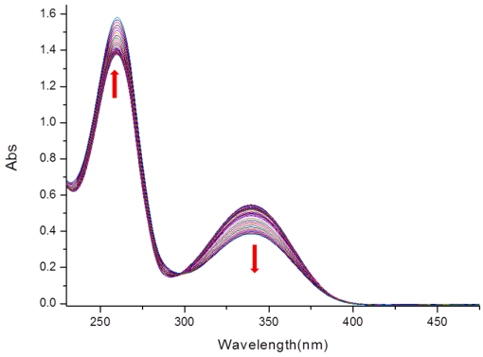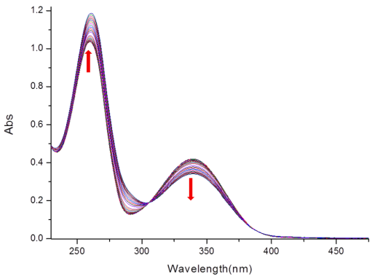

**(G) (H)**

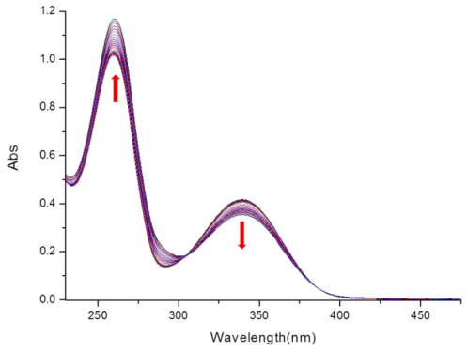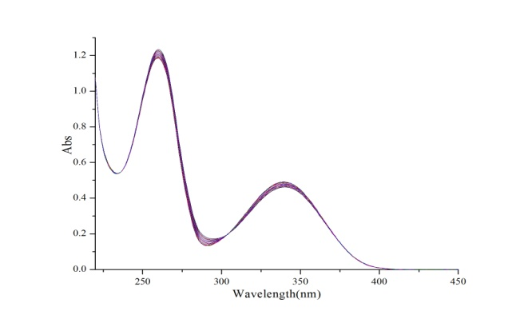

**Figure S3.** UV/Vis spectra of the reaction of NADH (87 µmol/L) with (A) **A1**, (B) **A3**, (C) **A4**, (D) **B1**, (E) **B2**, (F) **B3**, (G) **B4** and (H) NADH (as control) in MeOH/H2O (1.6 : 98.4) at 298 K for 8 h.

**A1 A2**



**A3 A4**



**B1 B2**



**B3 B4**



**Figure S4.** The IC50 graphs of all compounds **A1-B4**.